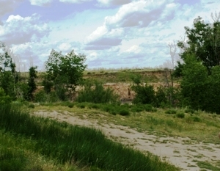
1935--county buys 662 acres of land for the lake and a park
Feb 13, 1936--plans have been drawn and labor is being secured
Mar 5, 1936--rock is being quarried and the ground cleared
Mar 19, 1936--work begins with 40 men
Oct 22, 1936--Dirt is being removed at a rate of nearly 1,500 cubic yards per day. All dirt must be removed to the bed rock. Clay is being hauled for filling in the core of the dam. Rock is being blasted to make the spot level and a power shovel is promised for arrival next week.
Jan 14, 1937--120 men are now working
Feb 1937--a light plant is installed so the men can work 24 hours a day and preparations are made in case there is spring flooding
Mar 1 1937--WPA refuses to grant additional money and work slows down. There is a fear the project will not be completed
June 3, 1937--rains threaten dam, only the south bank sustains much damage. The fill stands 15 feet high and work progresses about 2 feet per week.
June 10, 1937--water caused damage by burying two pumps in the mud and displacing about 5,000 yards of rock
June 1937--labor troubles cause WPA to stop for 7 weeks
July 8, 1937--Manter Dam is becoming a favorite recreation spot after floodwaters provided a swimming hole. Fishermen are enjoying the lake stocked with catfish and perch.
Oct 28, 1937--county commissioners were called to Topeka to discuss the fate of Manter Dam and returned with the understanding the project would be finished. The next week, the WPA shut down funding. Work continued with hand labor paid with county funds. The WPA soon refused to furnish any machinery and the project officially ceased the following August.

